Module 5 Project
Title: Comprehensive Security Assessment Using the MITRE ATT&CK Framework and STRIDE Threat Modeling and Designing a Secure Cryptographic Solution
Johnna Auman – 11/2/2025
Executive Summary:

Summary of security solutions proposed in the redesign. XYZ Corp's current hybrid infrastructure presents significant risks due to outdated tools, limited visibility, and misconfigurations. The recent incidents are symptoms of a foundational lack of a proactive security posture. This proposal outlines a strategic shift from a reactive to a proactive, defense-in-depth security model. The core recommendation is to adopt a Zero Trust architecture, leveraging modern Azure security services and integrating on-premises systems. This will enhance visibility, protect sensitive financial data, and bolster resilience against ransomware and unauthorized access.

There are comprehensive phases that need to be implemented. These include:
  - Asset and Data Inventory
  - Vulnerability and Configuration Assessment
  - Identity and Access Management (IAM) Review
  - Network Security Analysis
  - Current Tooling Evaluation
  - Infrastructure Redesign for a Zero Trust Model
  - Enhanced Visibility, Monitoring, and Response SOPs

For XYZ Corp, securing sensitive financial data is not just an IT issue but a core business imperative. By adopting this phased, Zero Trust approach, the company will transform its security posture from one of limited visibility and reactivity to one of comprehensive control, proactive monitoring, and automated response. This will significantly reduce the risk of future ransomware and data breach incidents, protect the company's reputation, and ensure compliance with financial industry regulations.

Network Security Assessment & Design:

Current Network Diagram
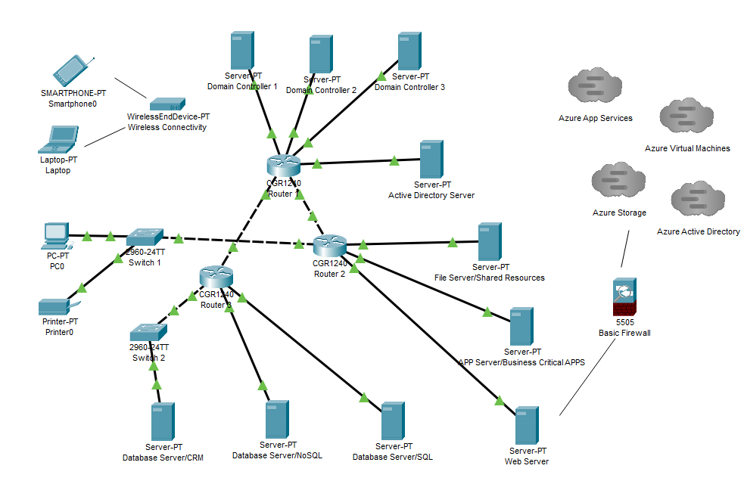

Gap Analysis Using MITRE ATT&CK & STRIDE
  - Also included in attached “MITRE_ANALYSIS_JohnnaAuman.xlsx” Sheet 1
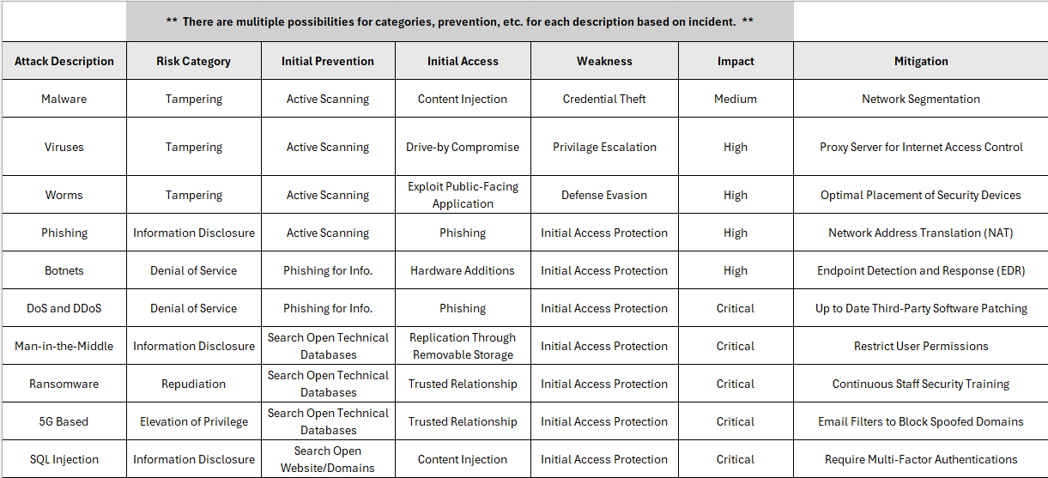

Redesigned Infrastructure Diagram
  - New Infrastructure shows security both inside and outside of Network
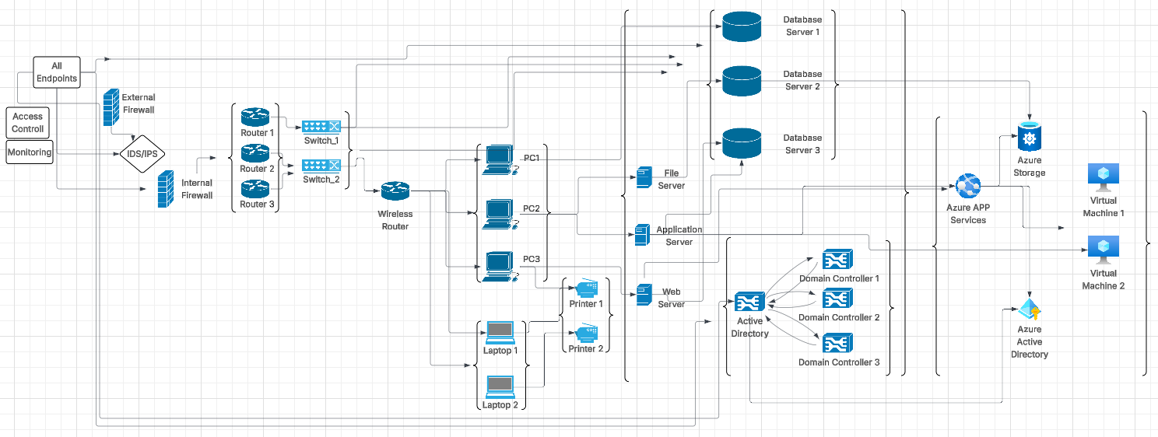

Justification of Security Solutions & Cyber Tools:

- Also included in “MITRE_ANALYSIS_JohnnaAuman.xlsx” on Sheet 2
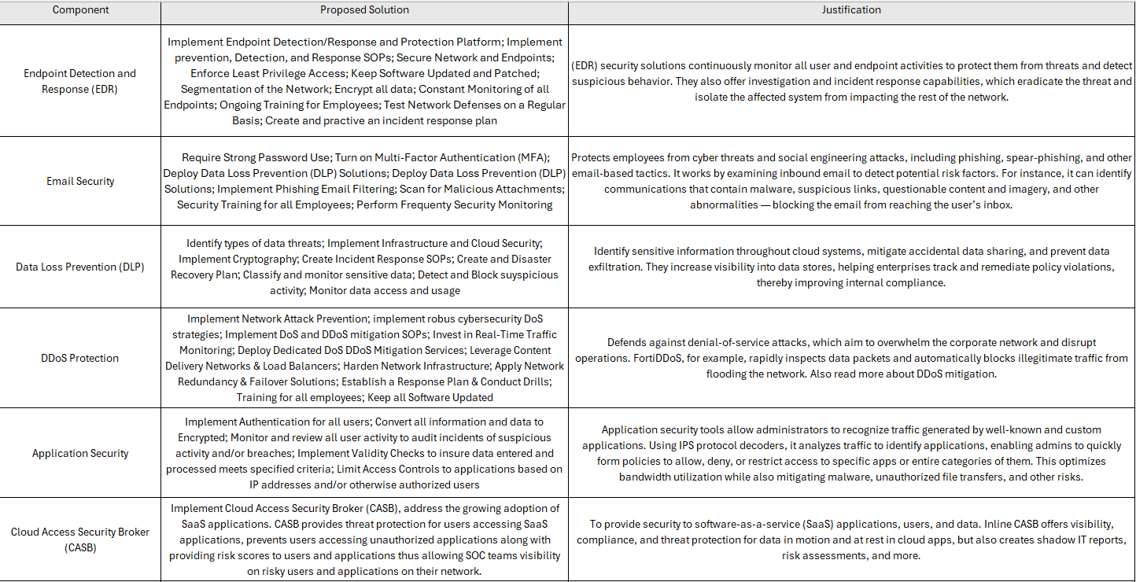

Cryptographic Implementation Report:
- See attached document “Module 5 Project_CyberChef_JohnnaAuman.docx”

Lessons Learned & Conclusion:
The main challenges were that the Legacy System in place was very unsecure. There was a lack of Unified Identity Fabric due to poorly configured hybrid state leading to inconsistent authentication policies and difficulty tracing user actions across systems. Along with Cryptographic challenges that were outdated and week making financial applications difficult to patch or replace. Encryption keys for critical databases were often stored on the same server as the data itself. There was no centralized key management.

The keys for planning included implementation of Compliance and Security; Visibiltiy at the foundation; Realizing the Human Layer as a Primary Attack Source; Ongoing updates and improvements based on changes inside the network as well as outside. It was critical to adopt a “Never Trust, Always Verify” strategy. Implementation of Unified Security Operations Center (SOC) to log data from all sources. Anti-phishing protocols including multi authentication applications and security keys. Overall taking a full review of the entire network and where and to where the data is traveling, how the data is accessed, the access levels for employees, and overall control of the security of the network needed to be put in place as a solid foundation on which to build in the future.

